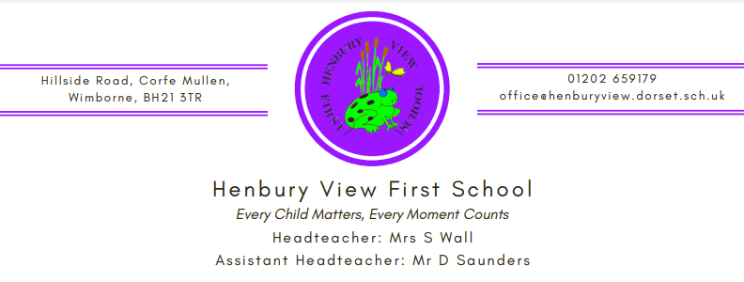

26th May 2023

Dear Year 2 Parents & Carers,
I am writing to let you know that over the next half term Year 2 will be having PSHE sessions about ‘Changes’, including information about girls’ and boys’ bodies.
Please see below for a little more information on the content of our sessions. Our policy states that our approach to Sex Education is primarily to help children cope with the physical and emotional challenges of growing up. Sex education will not be taken out of context or over emphasised in any way. It will sit firmly within our PSHE programme, which takes directive from the National Curriculum which all children of this age follow.
The lessons will provide simple information for the children and also give them a supportive forum if they wish to ask any questions.
Relationships Education is compulsory in all primary schools in England. However, parents have the right to request their child be withdrawn from some or all of the Sex Education that is being delivered. If you decide to withdraw your child from some or all of the Sex Education lessons or would like to discuss the sessions further then please email office@henburyview.dorset.sch.uk by 6.6.23 and address the email to your child’s class teacher. At Henbury View, we strongly recommend that all pupils are involved with Sex Education lessons.
Year 2 – ‘Changes’ sessions will cover;
- Recognising the physical differences between boys and girls
- Using the correct names for parts of the body
- Knowing that some parts of the body are private
More information about these sessions can be found within the accompanying PowerPoint.

Yours faithfully,
Miss Ellie Biles

