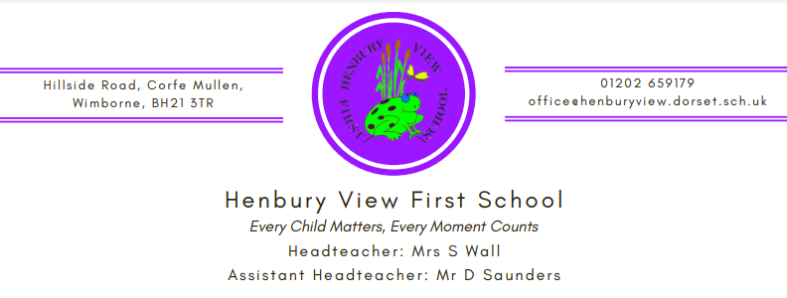

26th May 2023

Dear Year 4 Parents & Carers,
I am writing to let you know that after half term Year 4 will be having PSHE sessions about ‘Changes’, including information about puberty, menstruation and sexual relationships. Please see below for a little more information on the content of these session. Our policy states that our approach to Sex Education is primarily to help children cope with the physical and emotional challenges of growing up. Sex education will not be taken out of context or over emphasised in any way. It will sit firmly within our PSHE programme, which takes directive from the National Curriculum which all children of this age follow. The biological aspects of sex and reproduction have been covered as required in Science lessons.
The lessons will provide simple information for the children and also give them a supportive forum if they wish to ask any questions.
Relationships Education is compulsory in all primary schools in England. However, parents have the right to request their child be withdrawn from some or all of the Sex Education that is being delivered. If you decide to withdraw your child from some or all of the Sex Education lessons or would like to discuss the sessions further then please email office@henburyview.dorset.sch.uk by 6.6.23 and address the email to your child’s class teacher. At Henbury View, we strongly recommend that all pupils are involved with Sex Education lessons.
Year 4 – ‘Changes’ sessions will cover;
- The internal and external parts of male and female bodies that are necessary for making a baby.
- Vocabulary used will be; Sperm, Egg, Penis, Testicles, Vagina, Womb, Ovaries, Making love, Fertilise and reproduction.
- The changes that girls’ bodies go through in order for them to have children and that menstruation is a natural part of this.
- Vocabulary used will be; Puberty, Menstruation, Periods, Cervix, Uterus, Fallopian tubes and Ovaries.
- Emotional changes and challenges and strategies to deal with them.
More information about these sessions can be found within the accompanying PowerPoint.

Yours faithfully,

Mrs Laura Dawson and Mrs Melissa Hay

