Home learning – Foundation Class – Summer Term – 13th July 2020
It’s Summer Time!
Hello everyone! Here we are at the end of the summer term with our final learning pack for Foundation. We hope that you have all had a good week and have done some fun things together and that you have a safe and happy summer break too. This week, we have put together a pack of fun activities that you can pick and choose from. Whatever you do together, have fun and enjoy it. Remember to use the thinking hats (detailed below) to support your children with their reflections. There is also a challenge from Mrs. Bargewell as well as a summer activity book (from Twinkl) if you need further ideas and activities. As always, it is lovely to see some of the learning the children have been doing and if you need any help or support with anything, please get in touch either by phone on 01202 659179 to speak with one of us or of course, by email either to the office (office@henburyview.dorset.sch.uk) or myself (s.lucas@henburyview.dorset.sch.uk ) at any time.
As always, please do what works best for you and your child, have fun together and go with their interests and motivations using this learning pack to support as works best for you.

Foundation reflections…
My favourite topic or learning activity in school was …

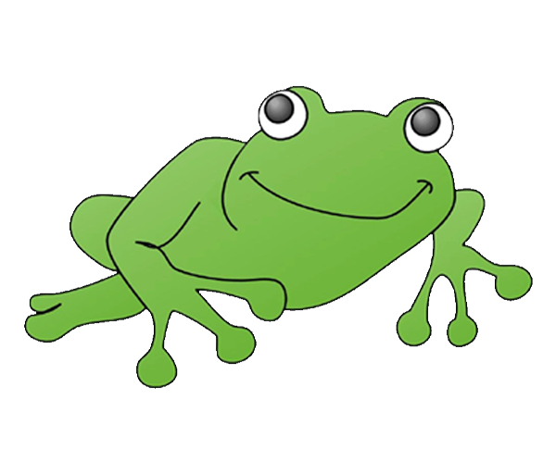 Welcome to Henbury  Tell me a story

Dinosaurs! 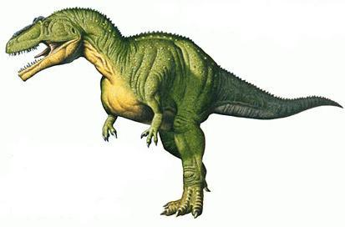 Rhyme Time 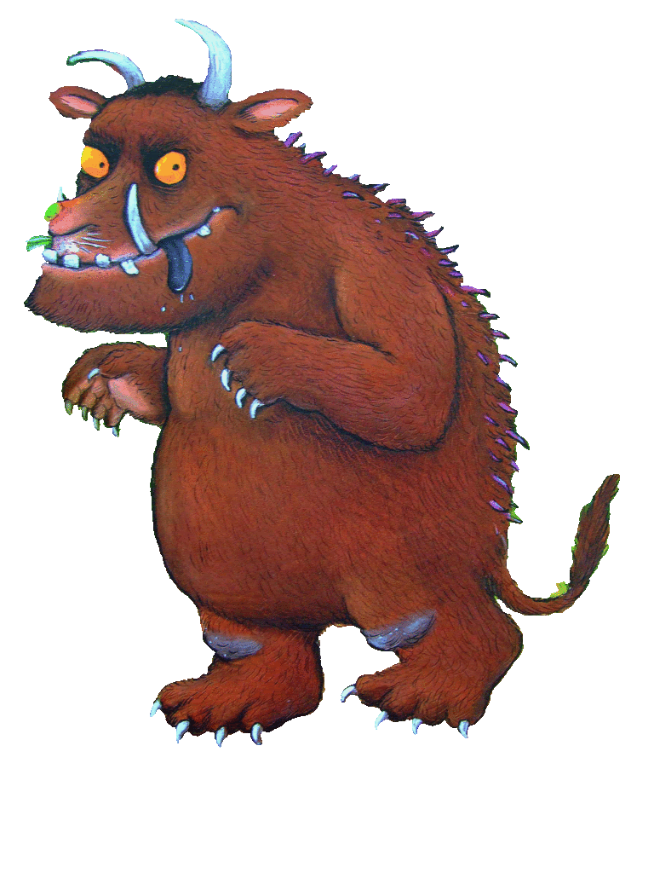

The best things I learned when I was at home were …

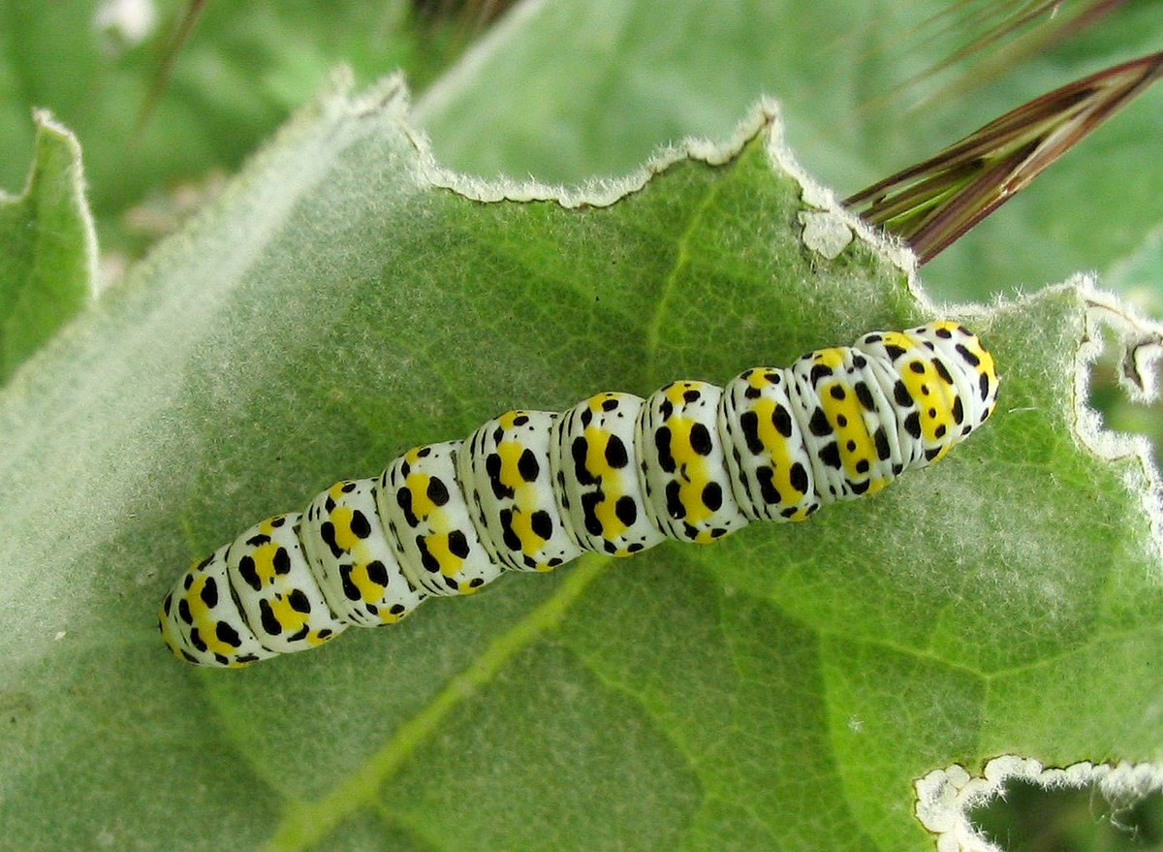

Things I like to do in school are …

Things I like to do at home are …

My favourite book is …

It is about ___________________________________

Here is a picture of my favourite character …

I like it because _______________________________

___________________________________________

This is a picture of me…

I’m a super star because …

My friends are …

This year, something new I have learned is …

Next year I would like to get better at …

Can you think of 10 fantastic things that you can remember about being in Foundation. It could be anything – things you liked to do, people you like to be with, games you liked to play, Write them down, or draw them, with your favourite at the top…

1 _____________________
2 _____________________
3 _____________________
4 _____________________
5 _____________________

6 _____________________
7 _____________________
8 _____________________
9 _____________________
10 _____________________

Take some time to think about some of the things that you are looking forward to doing in year 1 with Mrs Collins, Mrs Champion and Mr Dennis.

Me and my family …

Over the summer I will …

Next year I want to learn about …

I wish Mrs Collins knew that …

Ruth Miskin Read Write Inc website - https://www.ruthmiskin.com/en/ for support with phonics and reading as well as how to say the sounds and blend to read words.

Below are some general resources, ideas and online sites that may be helpful to you when supporting your children at home.

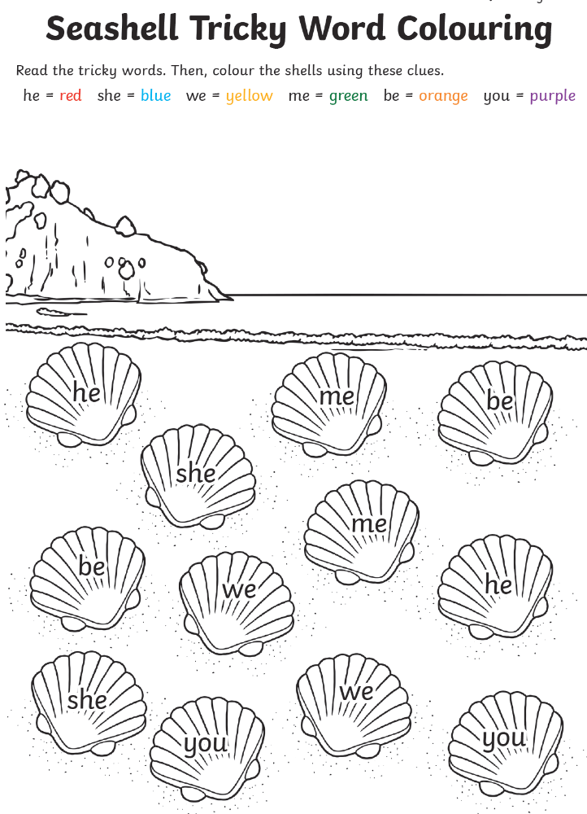

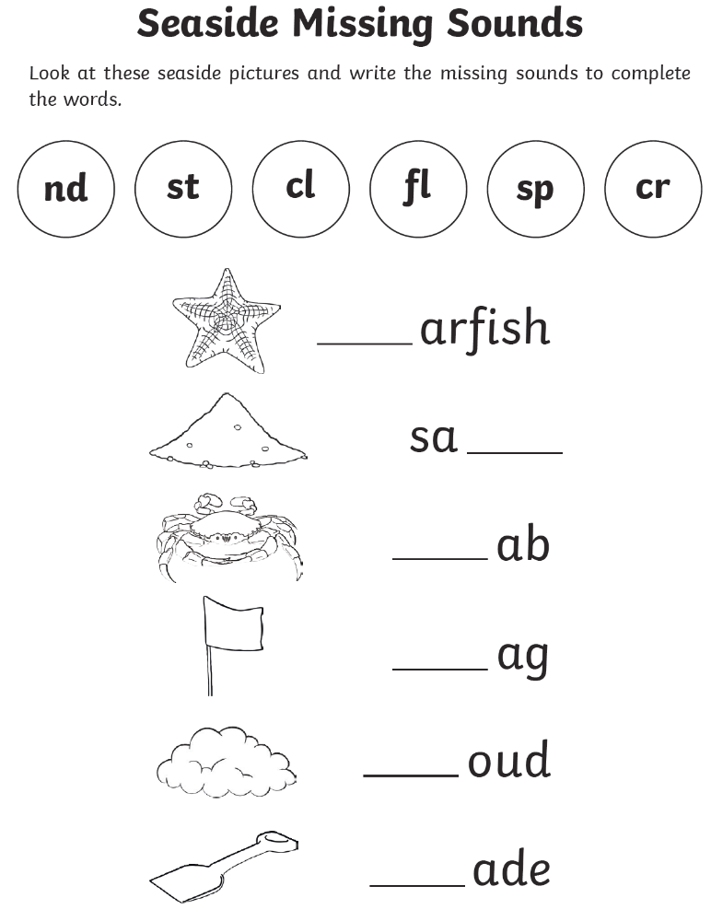

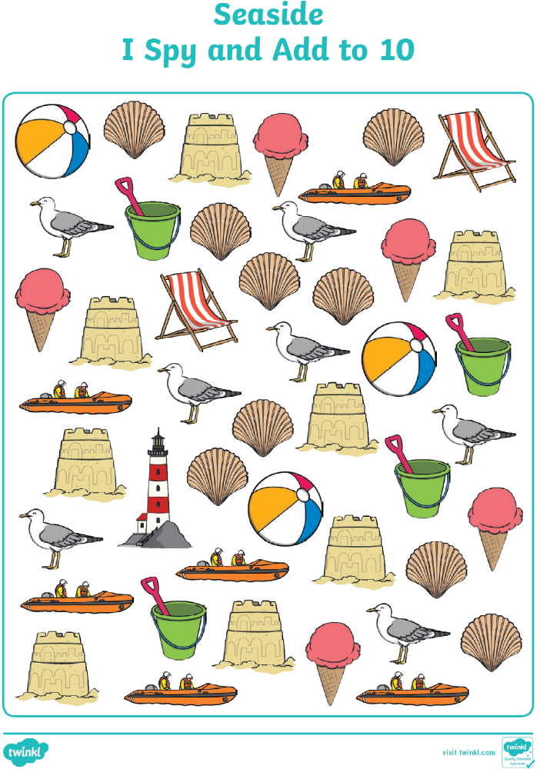
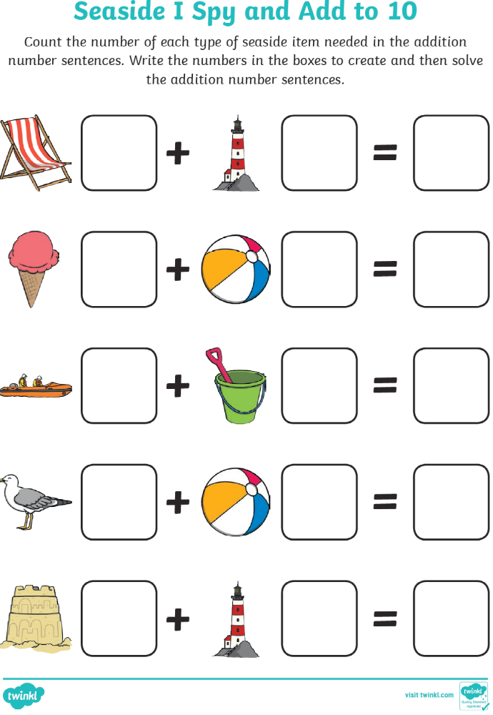
Here are two investigations to try out

Floating flowers

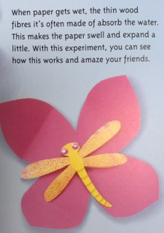

1 Cut out a square of paper about 15 cm x 15 cm. Fold it in half one way and then in half again

2 Draw a petal shape away from the folded corner. Cut around the shape to make the flower

3 Open out the paper, folding the tip of each petal in to the middle point (where the folds cross)

4 Next make an insect to hide in the middle… like the ones in the pictures

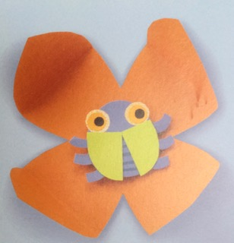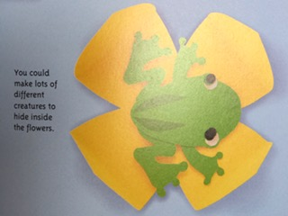

5 but the bug inside the folded flower and fold down the petals to cover and hide it. Fill a tray with water and lay the folded flower on top.

6 Wait and watch. What has happened? As the fibres in the paper soak up water, they swell and the paper expands which opens the paper flower up to reveal the creature hiding inside. Try it with different types of paper and different creatures hiding inside.

How to make a butterfly feeder

1 Take a plastic cup and make holes on opposite sides of the rim. Then tie a piece of string through.
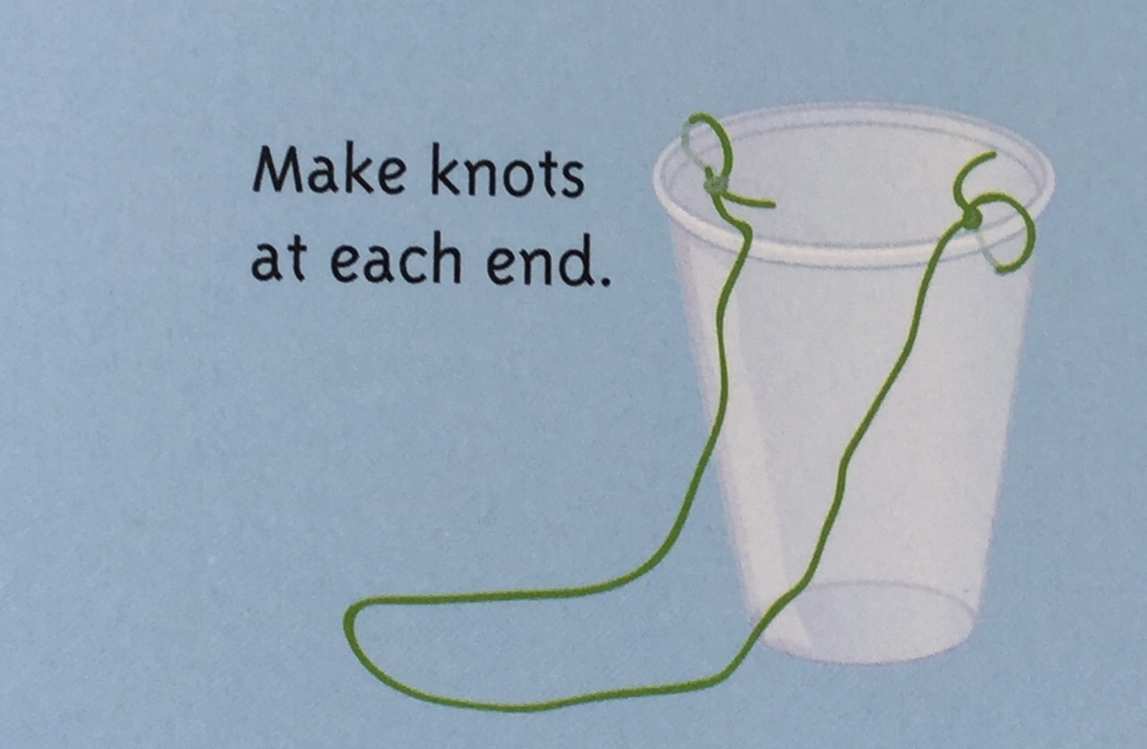

2 Make a hole in the bottom carefully and push a small cotton wool ball into the hole so half is inside the cup and half is poking out of the bottom

3 Cut out petal shapes from colourful plastic bags

4 glue them to the cup around the cotton ball to make a flower shape

5 make some sugar water … as below … and pour into the cup

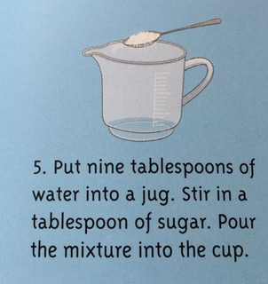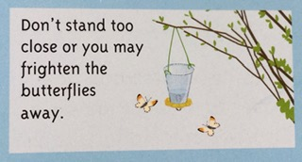

6 Hang the feeder from a branch of a tree or bush. Check on it from time to time during the day. Are there any butterflies feeding? Use the space below to draw your feeder and any butterflies that you saw.



Why not try making a tasty snack using some healthy fruits, vegetables and other tasty treats.

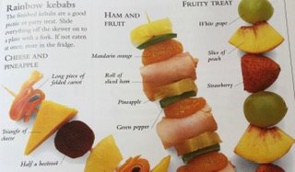

Here are some ingredients you could use:

Washed and prepared fruits such as
Strawberries
Raspberries
Melon
Oranges
Apples
Pears
Peaches
Nectarines
Pineapple

Washed and prepared salad vegetables such as

Cucumber
Tomatoes
Red or yellow peppers
Baby beetroot
Baby sweetcorn
Olives

Some other tasty things to include could be

Roll of sliced ham
Mini sausages
Triangles of cheese
Slice of salami
Cubes of mozzarella

When you have made your snacks, take a
photo and write a review of how they taste.
What different things could you add?

Why not try some of these ideas.

Make a self portrait – you could try sketching whilst looking in a mirror, or looking at a selfie. Print a picture of just your head and shoulders, stick it on a page then draw or paint on your body, arms and legs. You could try using these ideas too…

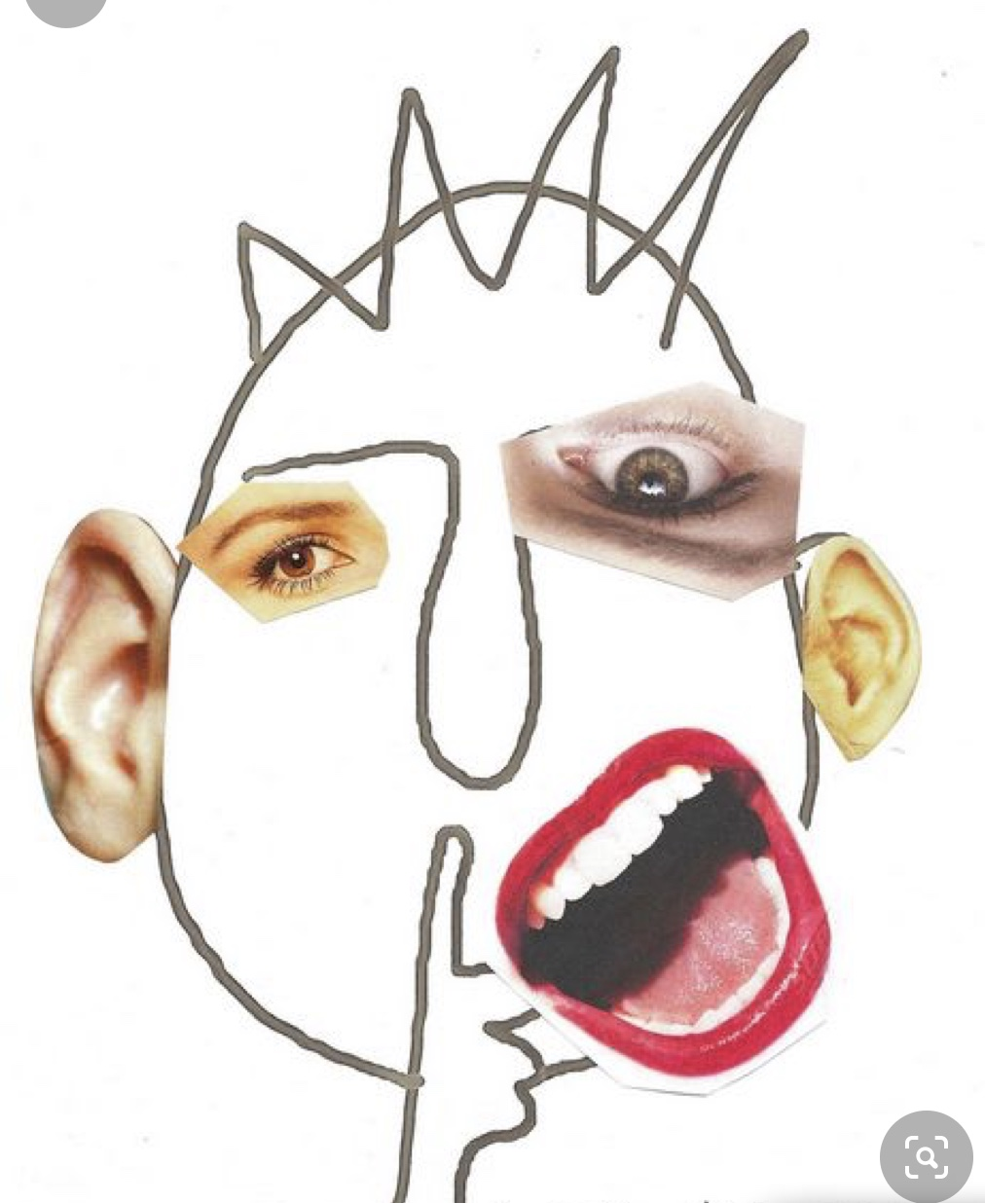
Cut out some features from old magazines, then draw your head and hair and stick on the features. How do you look?

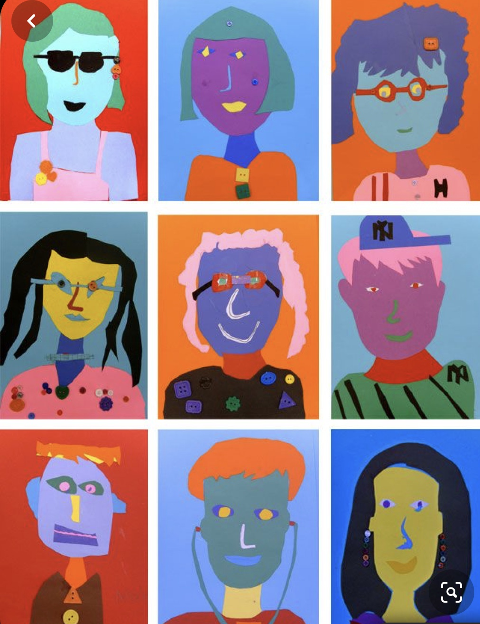
Try making a paper portrait. Use different types and colours of paper to create a self portrait. Remember to look in the mirror or at a picture of yourself to see the shapes you will need to use.

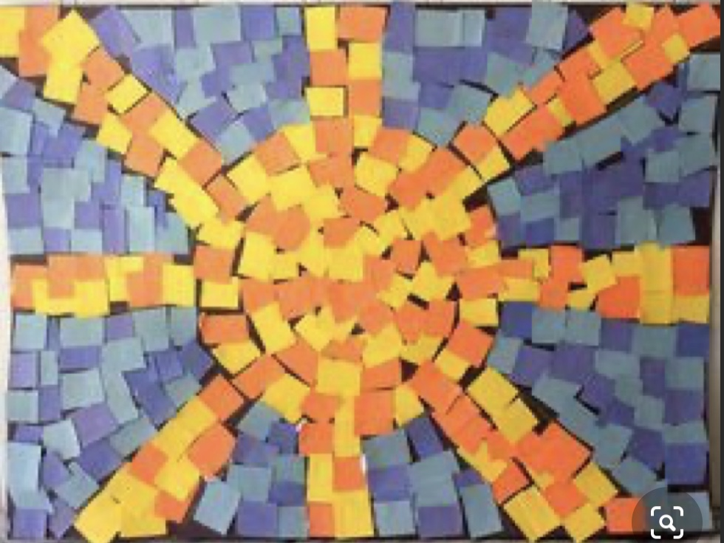
Create a mosaic using small squares of different types and coloured paper. You could make a sunshine, an animal, a flower, a lighthouse, your favourite superhero, a house, a rocket or anything at all, even a pattern.

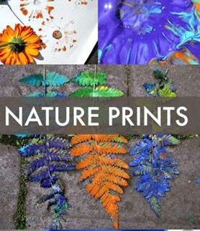
Use different leaves, flowers or other things you find in the garden to create prints or patterns. Press them into some paint, then print onto some paper. Use the different shapes you make to create a picture.
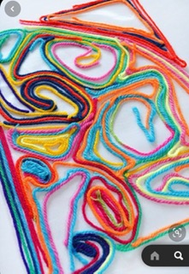 Have fun and remember, send some photos of your amazing artwork!
Make a ‘scribble’ pattern – you could use a pen, paint or try some different coloured string, wool or ribbons. You could also add sequins, old buttons or other things to make it more interesting.

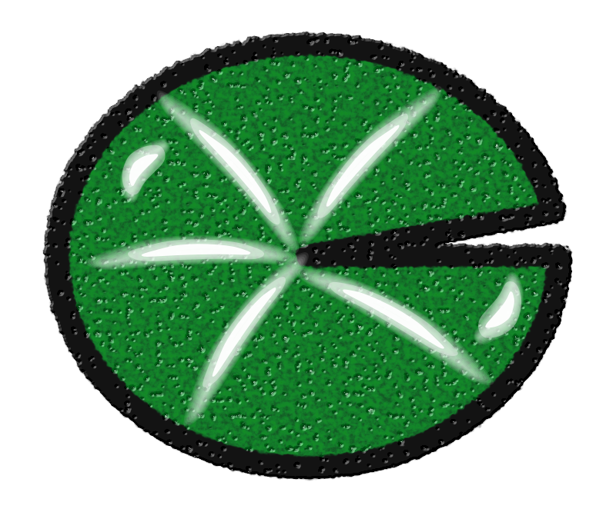Take some time to reflect on your first year as part of the Henbury community. Try to think about yourself as a learner and write down some of the ways that you have changed and grown over the last year. You could use the lily pads and thinking hats to help you.

Reflective Resourceful Reciprocal Resilient Responsible

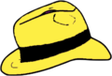

Planning Facts Creativity Positive Caution Feelings

