Year 3 Learning Pack
Week Beginning: 13th July 2020

English – Prepositions, Reading Comprehension
- Preposition Postcards
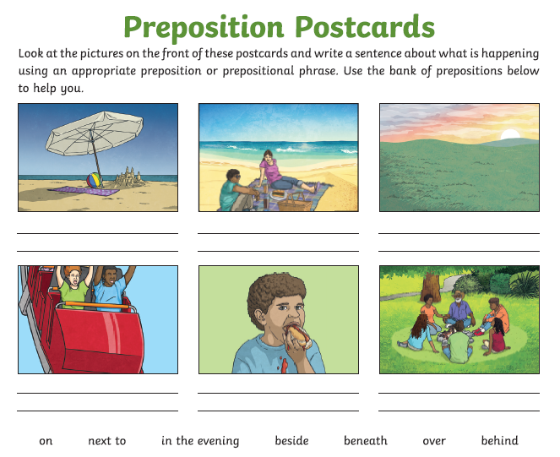

- Postcards
Write a postcard to your new teachers. You could tell them about yourself or about something you hope to do in the summer. Try and use some of the above prepositions in your own writing.
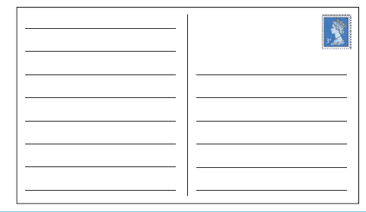

- Reading Comprehension

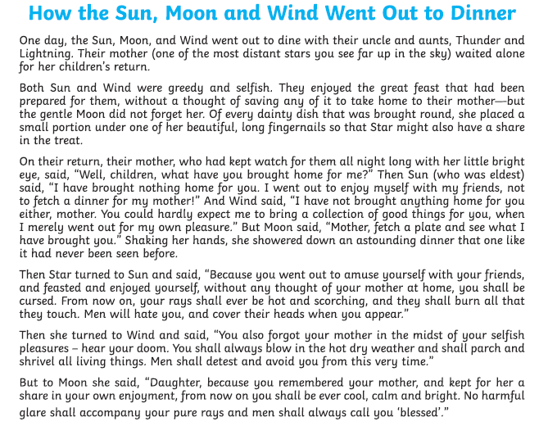
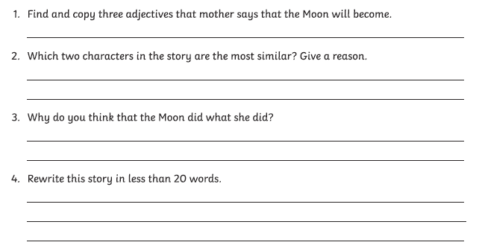

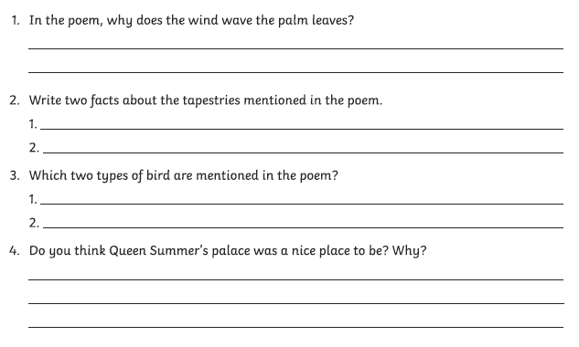
- Poetry – Reading Comprehension
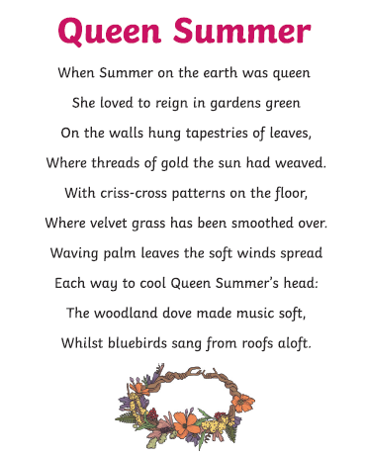

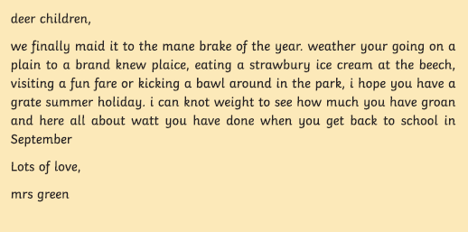
- Editing Mistakes – Punctuation & Homophones

Please read the above letter from a teacher to her class. Can you spot her many mistakes? Think carefully about your understanding of homophones – words which sound the same but are spelt differently and have a different meaning.
You may choose to write this short extract out again without the mistakes.

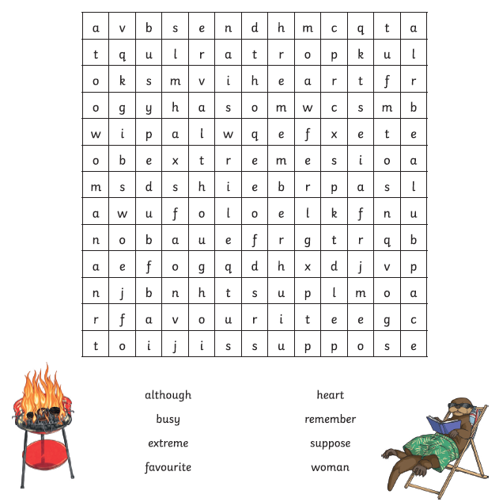

Maths – Summer themed multiplication & division focus
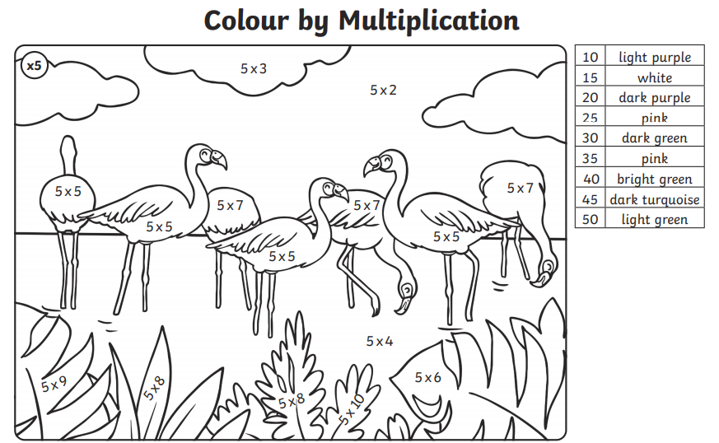
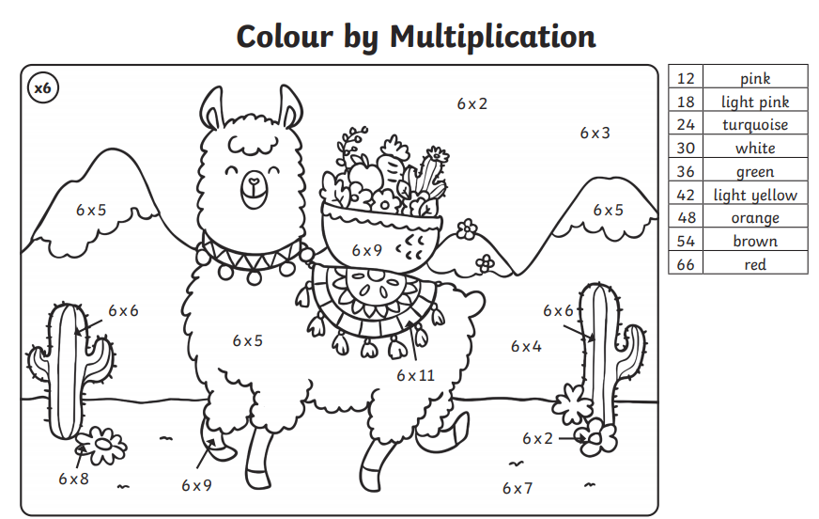

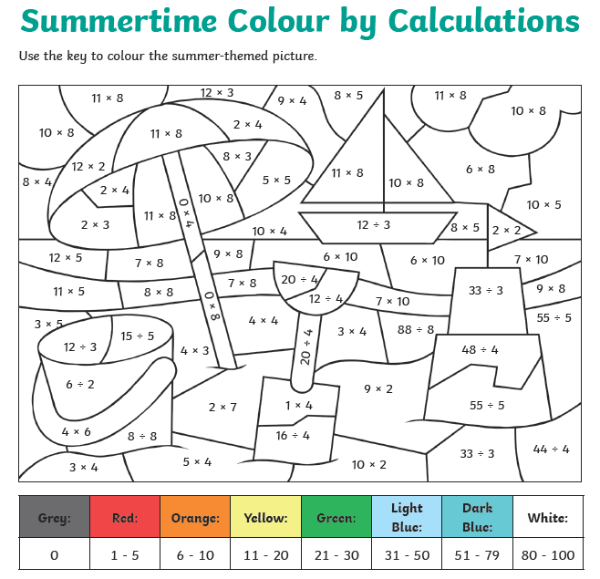

Multiplication & Division Mosaic

Solve the problems and then use the key to identify which colour to shade each square. Can you reveal the hidden picture in the mosaic?
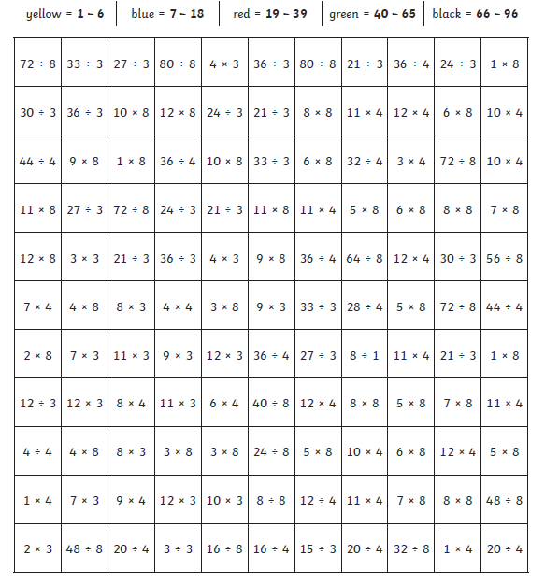

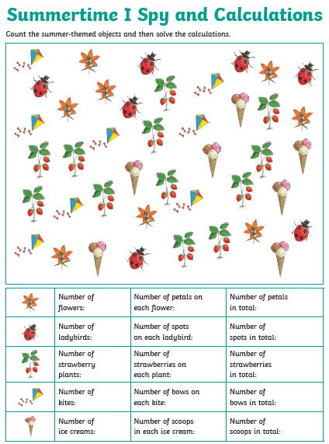

Multiple Dot To Dot
Practise counting in multiples of 3 and connect the dot to dot at the same time. Challenge yourself to make your own dot to dot going up in multiples.

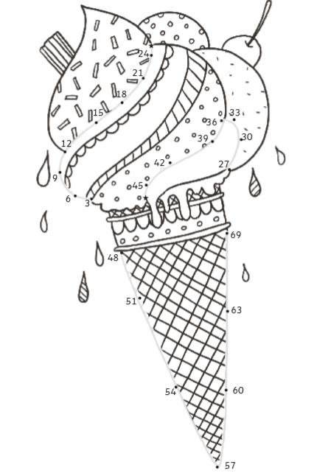

Salt Dough Fossils
Try visiting the link below to find out how to make your very own fossils. You could use anything to create the print in your fossils – leaves, shells, or toys. Once you have made them, you can pretend to be a paelonotogist learning about the past through your discoveries
https://www.littlepassports.com/blog/craft-diy/make-dinosaur-fossils-using-salt-dough/

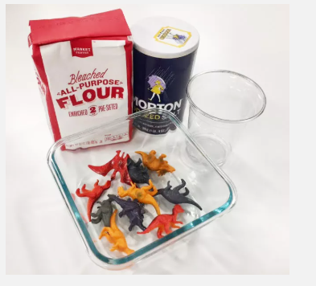

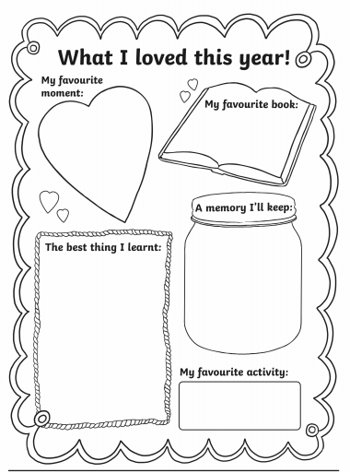
Reflection
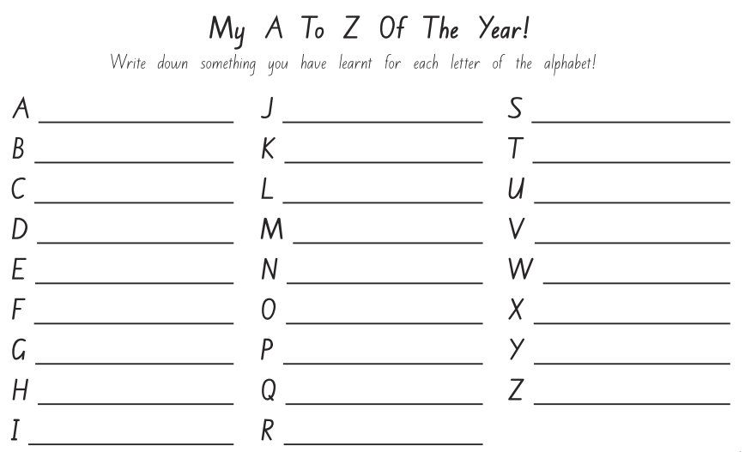

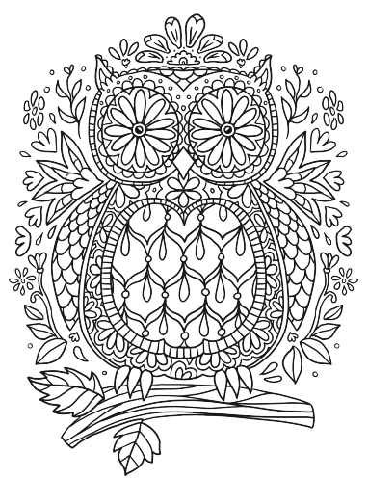
Mindfulness Colouring



