INTENT  The children will develop their historical inquiry skills and knowledge as they learn about World War 2. They will evaluate the impact that it had the children who were evacuated and how it changed their lives forever. As historians they will need to be resourceful in their approach, asking appropriate questions and using appropriate sources to locate information. They will immerse themselves in the evacuation process, using drama and role play to imagine what it would have been like and how children who were evacuated must have felt. They will look at key events such as the Blitz, making connections between their learning about light and shadows and the need to shut curtains to avoid cities being recognised from the air. To deepen their understanding, the children will analyse decisions made during the war and reflect on whether they could have been done differently. | 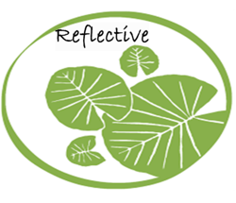  Independence | HISTORY
 |  | SCIENCE
 |  | PSHE
 |  | ENGLISH

HOOK
Day in the life of a 1940’s child. Children to experience what it was like to go to school in the 1940’s, make evacuee card, identity card and gas mask box, make food using rations
ESSENTIAL QUESTION/CHALLENGE
Can you investigate what life was like as a child evacuee?
OUTCOME
Anderson shelter making
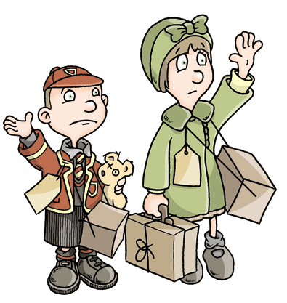
EXPERT INPUT
Visit from a relative who was in the war to answer questions about the WWII period and how things changed for everyone involved.
LEARNING THROUGH ROLE PLAY
- Regular drama slots to experience the emotional rollercoaster of the war, especially how the war affected children
- Role play area- Anderson shelter. Children to initially spend time in the role play using their senses and imagining what it was like to spend time in an Anderson shelter

Year 3
World War II
Autumn 2,
Learning in action. Developing an Inquiry Mind-set:  1. Knowledge (remember)  When was World War 2? How long did the war last?  Can you locate the countries involved in the war?  How did the war start/finish? Which country declared war first?  How did people find out that the war had officially started?  What is light? What is a shadow?  Where does light come from?  2. Comprehension (understand)  Explain why people ignored the news  Why did people want to become soldiers in the war?  Why was the evacuation process necessary?  Why is light important?  Why can light be dangerous for us and how can protect ourselves?  What was it really like?  Can you describe how they felt about leaving their families?  3. Application  Draw a timeline of the events  Colour in a map to show the countries involved in the war  What would you ask Adolf Hitler or Winston Churchill?  Investigate how shadows form and how shadows change  Can you use your own feelings to consider how the children must have felt leaving their families?  Can you compare and contrast life in the 1940’s to family life now?  4. Analysis (outcome- parent share)  What impact did the war have on society? How did the children cope with being evacuated?  5. Synthesize (create)  Design a poster encouraging people to listen to advice given during the war  Create a product to help protect us from the dangers of the sun  Write a diary entry as a child experiencing events during the war  6. Evaluation  Do you think there could be another world war?  What are the different uses of light? What would life be like without light?  If you could go back to 1939, what advice would you give the children who lived in London? | As historians we will:  - Research World War II-what, who, where, when, why  - Take part in role play imagining events like the blackout, air raid sirens, being evacuated and leaving parents  - Research and ask questions about how people lived in 1939 and how that changed during the war.  - Research and ask questions about who made big decisions in the war and how those decisions affected the people of Britain  - Analyse the different advice that was given to families and reflect on whether we would follow the same advice today  - Place World War II on a timeline of historical events we have learnt about so far and order the important events of the war chronologically  As scientists we will:  - Discover how light is an essential part of life for many reasons, looking at how our eyes need light  - Look at reflection and how light reflects, conducting an experiment to see which materials are most reflective  - Determine how light from the sun can be damaging to humans and how we can protect ourselves  - Research shadows, discovering how they are formed and trailing making our own shadows and shadow puppets  - Investigate how shadows differ depending on different factors (e.g. size of object, strength of light source, distance of object from light source)  As reflective learners we will:  - Compare and contrast family life in the 1930’s/40’s with our own families. Discuss the role of different family members and identify what a stereotype is and how it has changed over time. Look at how the war changed this also  - Take part in hot seating and role play to experience how family felt about the evacuation | Curriculum Objectives:  History  World War 2  - a study of an aspect or theme in British history that extends pupils’ chronological knowledge beyond 1066  Science  Light  - recognise that they need light in order to see things and that dark is the absence of light  - notice that light is reflected from surfaces  - recognise that light from the sun can be dangerous and that there are ways to protect their eyes  - recognise that shadows are formed when the light from a light source is blocked by an opaque object  - find patterns in the way that the size of shadows change  PSHE  - That stable, caring relationships, which may be of different types, are at the heart of happy families, and are important for children’s security as they grow up  - What a stereotype is  - That families are important for children growing up because they can give love, security and stability  - The characteristics of healthy family life, commitment to each other, including in times of difficulty, protection and care for children and other family members, the importance of spending time together and sharing each other’s lives  - That there is a normal range of emotions (e.g. happiness, sadness, anger, fear, surprise, nervousness) and scale of emotions that all humans experience

  How we evaluate?  *Thinking Hats will be used to reflect upon our overall outcomes at the end of the learning experience, ideas will be captured in their topic journals  *Peer and self-assessment will be used throughout the process  *Concept mapping will provide formative assessment opportunities as the topic progresses and allow children to learn how to organise their gained knowledge and understanding |   What Stuck with you?  - Children can explain how the war started and key events that happened throughout the war.  - 3rd September 1939 Neville Chamberlain declares war on Germany  - 10th July 1940 Battle of Britain begins  - 7th September 1940 the London Blitz begins  - 8th May 1945 Britain celebrates VE day  - Children can explain what light is and different light sources  - Children can explain how light reflects and how shadows are formed  - Children will be able to describe and reflect on how children felt about leaving their families and being evacuated to the city  Deeper Thinking  - Children can come to their own conclusion about whether the war would have happened differently if key people hadn’t made the decisions, they made  - Children can design and experiment to discover how shadows change and hypothesise why this is the case  - Children demonstrate a deeper knowledge of their understanding about the importance of family and how being evacuated to the country affected the children
Wider and Discrete Learning Opportunities:
Geography: to locate the world’s countries, using maps to focus on Europe (including the location of Russia, name and locate counties and cities of the United Kingdom, use maps, atlases, globes and digital/computer mapping to locate countries and describe features studied- countries involved in WW2, battle grounds

Art: to create sketch books to record their observations and use them to review and revisit ideas, to improve their mastery of art and design techniques, including drawing, painting and sculpture with a range of materials [for example, pencil, charcoal, paint, clay], about great artists, architects and designers in history- silhouette images to link to light

Music: appreciate and understand a wide range of high-quality live and recorded music drawn from different traditions and from great composers and musicians, develop an understanding of the history of music- music of the time (Very Lynn, Fred Astaire, Ginger Rogers)

