INTENT  The children will develop their scientific inquiry skills and knowledge as they learn about how to be healthy. They will consider what humans need to be healthy and apply this to their own lives. As scientists they will need to recognise the different things that keep us healthy and make connections across their learning before creating a healthy living plan for Mr Grinling. To deepen their understanding of why it is important to be healthy, the children will explore the effect that exercise has on our bodies through planning, implementing and evaluating science investigations. | 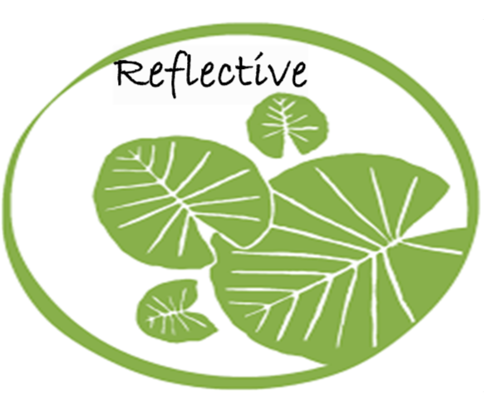  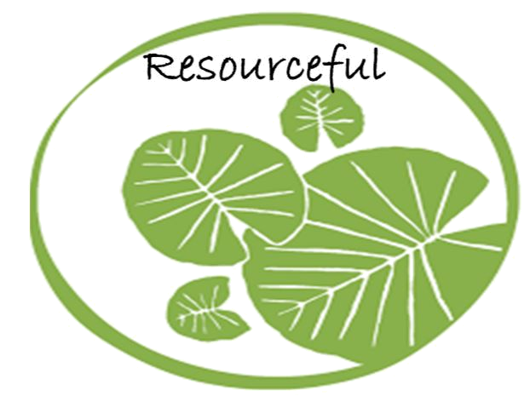  Independence | SCIENCE
 |  | ART
 |  | ENGLISH

HOOK

Basket delivered to school – Where has it come from? Who does it belong to? Include a letter at the bottom (find at the end of initial lesson) from Mrs Grinling explaining that she would like us to help her encourage Mr Grinling to lead a healthy life.

ESSENTIAL QUESTION/CHALLENGE

Can you formulate a plan to improve Mr Grinling’s wellbeing?
OUTCOME

Link to English: Create our own Lighthouse Keeper’s Lunch story and (deliver to the local library)

Create a healthy living plan for Mr Grinling to ensure that he lives a happy, healthy life.

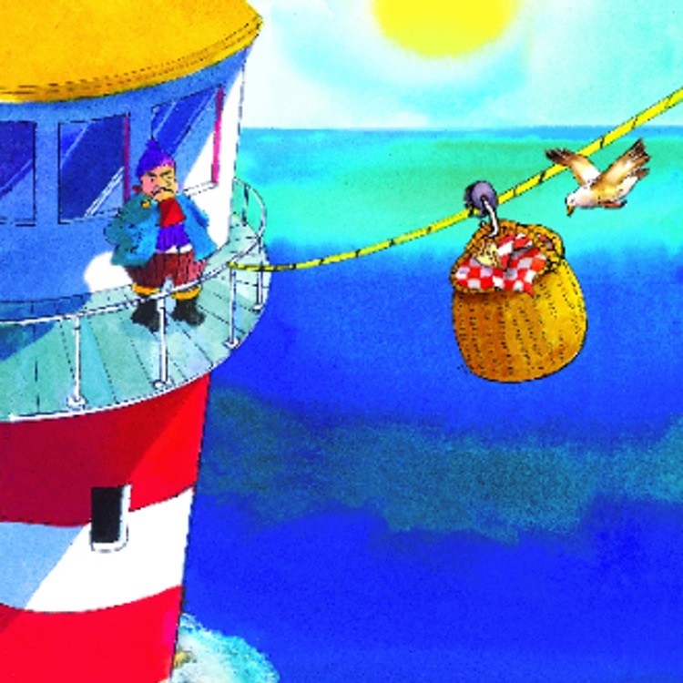
EXPERT INPUT

LEARNING THROUGH ROLE PLAY
*Regular access to role play – ‘Supermarket’ – Include activities such as sorting food into their food groups, writing a shopping list for a healthy packed lunch and buying food and receiving change (linked to maths).
*Hot seating characters from the book
Year 2
LHKL
Autumn 2

Learning in action. Developing an Inquiry Mind-set:  1. Knowledge (remember)  What are the five food groups?  Can you tell me one food from each food group?  What do you need to consider in order to be healthy?  What effect does exercise have on your body?  What are the basic needs of humans and animals to survive?  Identify the different ways that we keep ourselves clean.  What are the primary colours?  What colours do I need to mix to make purple?green? etc  How do you make a colour lighter or darker?  2. Comprehension (understand)  Describe what each food group provides you with.  Explain why some food groups are bigger than others.  Which two food groups should you have the most of? Why?  What would happen if you did not exercise enough?  Discuss darker and lighter colours as shades and new colours made  3. Application  What would you advise Mr and Mrs Grinling to change about their lifestyle?  Can you use your understanding of what the different food groups provide to explain what might happen if you didn’t eat one of them?  Complete a food diary and exercise diary for the week.  List the different things that we do at Henbury in order to be healthy.  What material can you use to make the sea? Sand? Land?  Can you try to replicate a colour by mixing and using shades?  Can you apply texture by using a sponge or cotton wool bud?  4. Analysis  Categorise foods into the different food groups.  Research different exercises and simple changes that could be made to Mr Grinling’s lifestyle.  What impact did unhealthy eating have on Mr Grinling’s life?  Research sea landscape paintings by famous artists like Van Gogh  5. Synthesize (create)  Design a healthy menu for school lunches.  Create a plan for Mr and Mrs Grinling to make sure that they are healthy.  Make a poster for the toilets to remind children to wash their hands.  Create your own water landscape picture taking inspiration from the Lighthouse Keepers story pictures.  6. Evaluation  Using your food diary, evaluate where you could make simple, healthy changes.  Using your exercise diary, evaluate where you could make simple, healthy changes.  What advice would you give to someone who was trying to make healthier choices?  Can you evaluate what went well about your painting and what you would like to improve?  Can you discuss strengths of your partners art work? | As Scientists we will:  *Describe what the different food groups provide you with.  *Investigate the effect that exercise has on your body.  *Consider what changes Mr and Mrs Grinling should make to their lifestyle.  *Design a healthy plan for Mr and Mrs Grinling including food suggestions and an exercise plan.  *Evaluate the amount of exercise that we do at school.  *Assess the different ways that we are healthy at Henbury  As Artists we will:  - Look at famous sea landscape painting by artists like Van Gogh  - Recap primary colours and what colours we need to mix to make certain colours  - Learn how to make shades of colour by adding black and white.  - Look at different everyday materials we can use to create texture to our painting. Also using sponges and cotton wool buds.  - Create our own sea landscape painting using the Lighthouse keeper stories as inspiration. | Curriculum Objectives:  Science: Animals, including Humans  - Find out about and describe the basic needs of animals, including humans, for survival (Water, food and air)  - Describe the importance for humans of exercise, eating the right amounts of different types of food, and hygiene.  - Find out about and describe the basic needs of animals, including humans, for survival (Water, food and air)  Art  - To develop a wide range of art and design techniques in using colour, pattern, texture, line, shape, form and space.  - To use a range of materials creatively to design and make products  - To use drawing, painting and sculpture to develop and share their ideas, experiences and imagination.  - About the work of a range of artists, craft makers and designers, describing the differences and similarities between different practices and disciplines, and making links to their own work.

How we evaluate?  *Thinking Hats will be used to reflect upon our overall outcomes at the end of the learning experience, ideas will be captured in their topic journals  *Peer and self-assessment will be used throughout the design process  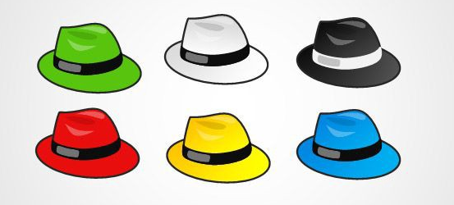  *Concept mapping will provide formative assessment opportunities as the topic progresses and allow children to learn how to organise their gained knowledge and understanding |   What Stuck with you?  * Children can describe the importance of eating a varied, balanced diet.  *Children can name and discuss the different food groups and what they provide their bodies with.  *Recognise the importance of exercise.  Deeper Thinking  * Children will be able to give advice to someone who wants to make healthy changes to their lives.  * Children will reflect upon and articulate the impact that unhealthy eating had on Mr Grinling’s life.
Wider and Discrete Learning Opportunities:
Music - Use their voices expressively and creatively by singing songs.

Geography- Research Lighthouses around the world.

Design and Technology - Technical knowledge: build structures, exploring how they can be made stronger, stiffer and more stable – Design and build a lighthouse

PSHE – Jigsaw learning

Computing – Use technology safely and respectfully, keeping personal information private; identify where to go for help and support when they have concerns about content or contact on the internet or other online technologies

