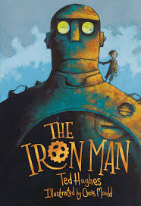English

**Writing**

In English, we will be building on the fictional skills learnt last half term to create a fictional piece of writing. We will use the book ‘The Iron Man’ by Ted Hughes as inspiration for our own imaginative writing. Through this learning journey, we will be exposing the children to Year 3 grammar objectives, for example the use of conjunctions and adverbials to show time, place and cause, the use of apostrophes for possession, descriptive language techniques and the use of paragraphs. We will also build in opportunities for the children to write explanation texts to describe the functions of their own imaginative robot where the children can draw upon the knowledge from our topic lessons and their imaginations to support them.

**Spelling**

This half term we will be starting to look at Year 3 spelling rules after consolidating our Year 2 rules. Our daily spelling sessions will involve us continuing with the Read Write Inc scheme; please continue to use the red spelling logs to help your child re-visit our spelling focus each week. We would ask if you could ensure that your child’s spelling log is in their book bag when they bring it into school on a Thursday as this is when we will update them.

**Reading**

Within our reading sessions this half term, we will be looking at the text ‘The Iron Man’ by Ted Hughes. This will also support our English sessions. We will be working on word reading and fluency as well as comprehension where the children will need to infer as to how characters are feeling based upon their actions, thoughts and motives. With this, we will work on supporting our inferences by using multiples pieces of evidence from the text.

Home Learning

You will receive a separate sheet of home learning ideas that could support the learning that we are doing in school. However, please only take these as inspiration and follow the children’s interests if they have their own ideas. Please continue to read as much as possible at home and practice the red words and the words in the spelling log each week. We would also appreciate any times table practice you could do at home, either verbal, written or using Times Tables Rockstars.

Maths

In Maths, we will be focusing on multiplication and division. We will begin by consolidating counting in multiples as well as continuing with our times tables practice. This will support us when we move onto the different formal methods of multiplication and division. We will first focus on multiplication, using the times tables we are familiar with to move towards formal methods (see example).

We will then move onto looking at division. We will ensure that the children notice the relationship between multiplication and division, where the children can use their times tables to derive division facts. The method we will be looking at is chunking (see example). This method allows the children to use their multiplication to help with division.

It is vital that children see multiplication as commutative (i.e. we can do it either way around- 2x7 or 7x2) but that division is not.

Topic

Our topic learning will take into the world of everything robots. Our key question for this half term is:

Can you judge how robots positively and negatively impact on today’s society?

All of our learning will help us to answer our essential question and the key driving subjects for this topic are Science and DT.

Within Science, the children will be learning about forces, friction and magnetic attraction through our topic this half term. They will learn about forces in the context of pushing and pulling and will identify different actions as pushes or pulls. The children will collaboratively work on an investigation about friction by exploring the movement of a toy car on different surfaces. They will also learn about which materials are magnetic and how magnets can attract or repel.

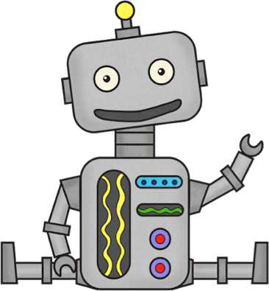In DT, we will ask all the children to design a robot with a purpose to promote at our Robot Convention. The children will need to come up with a design which incorporates a push, pull or magnet element. This will be developed in our Science work on forces and magnets. During this task, we will support them with their cutting, measuring, sticking skills, and help the children to ensure that their structures are secure. Planning is a vital skill being developed as are their abilities to evaluate their learning at the end.

**PE**

Warm clothing for outdoor PE is recommended when it starts to get colder. We ask if the children can bring their PE kits into school on a Monday and we will send them home on a Friday.

The PE days for this half term are:

* Monday (PM): Invasion Games (outside)
* Thursday (AM): Gymnastics (inside)

**Snacks**

In Year 3, the children are no longer provided with a free piece of fruit at snack time. Please send your child to school with a snack if you wish to, and we ask if this could still be a healthy choice.

Year 3

**Spring 1 Curriculum Leaflet**



Rise

of the

Robots

Thank you so much for all of your support last term and for your extremely generous Christmas gifts. The children have all settled back into school amazingly well and we look forward to another exciting half term ahead!

Mr Saunders Mrs Samways

Mr Guppy Miss Richmond

If you have any questions, or need to speak to us, please email either the school office or us directly at: [d.saunders@henburyview.dorset.sch.uk](mailto:d.saunders@henburyview.dorset.sch.uk)

[e.samways@henburyview.dorset.sch.uk](mailto:e.samways@henburyview.dorset.sch.uk)