INTENT  Developing an understanding of the seasons, specifically Winter, and using quality literature to support this learning is a key aim for this learning experience. The children will learn about the typical weather we see in winter and compare this to how other countries experience winter. The theme ‘Frozen Fever’ will be explored in a hands-on approach, with opportunities to observe states of matter and conduct their own experiments to answer question they may have around ice, as well as studying the design of snowflakes in order to create our own to hang in the classroom. We will spend time in class learning about story structure, start, middle and end, and use this knowledge to recite our main text, ‘Lost and Found’. With the start of the new year, the children will learn about aspirations, with the opportunity to set their own goal for 2022 and how they might achieve it. Studying the weather changes outside will provide opportunities to explore language and start to use adjectives within our talk. This learning journey will contribute towards our understanding of the world and provide excellent opportunities to progress our Literacy, Maths and communication and language skills. | 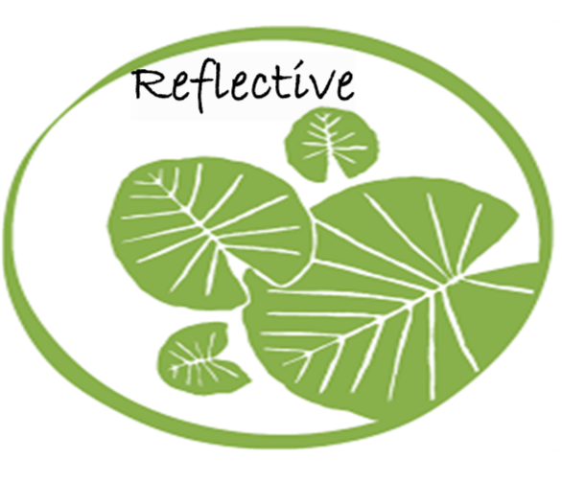  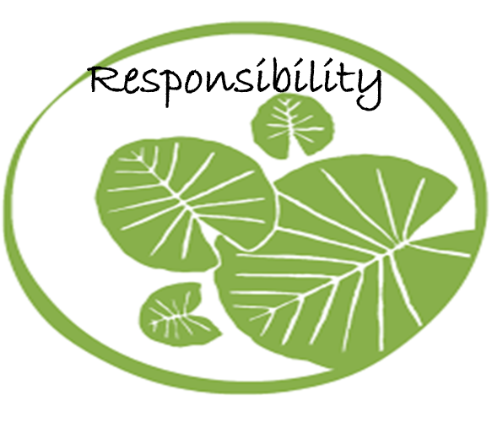  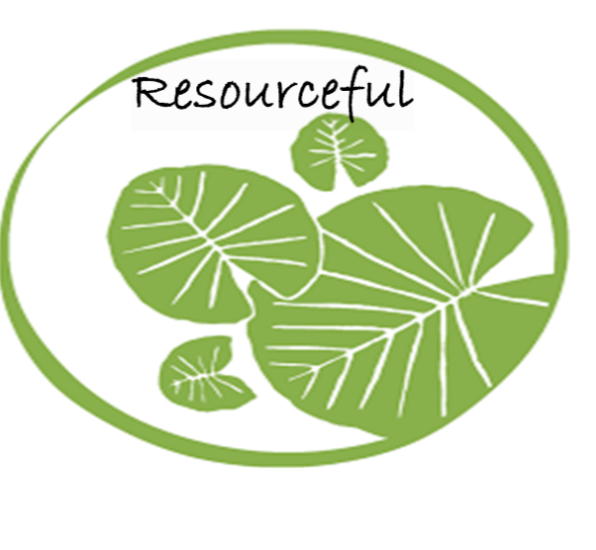

HOOK
Snow prints on the floor will lead children to the Penguin from ‘Lost and found’ (by Oliver Jeffers) is in our classroom but is homesick. It is carrying a letter asking Foundation to find out what the South Pole looks like, and to help turn the classroom into the South Pole.
Where is the south pole? What do we need to make the classroom look like the South Pole? Children to spend the day time looking at a map, finding clues as to what the South Pole is like, and building igloos for the Role play and Reading corner.
Lines of Inquiry
What happens in winter? Does winter look the same all over the world? What happens when it gets really cold, such as below 0 degrees Celsius?
OUTCOME
The children will be able to create a picture of a Frozen winter scene, using adjectives to describe their design choices.
The children will write a letter to Penguin describing what winter has been like in Corfe Mullen, England.

EXPERT INPUT
A visit from the new headteacher and deputy head. This is to make the children aware of the new Senior Leadership team.

LEARNING THROUGH ROLE PLAY
South Pole – Igloo building, using sticks to make a campfire, the children can make snowflakes and snowballs from paper.

Ice castle – dressing up, laboratory, experimenting with ice, melting ice, making ice potions.

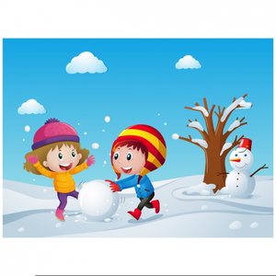
EYFS
Frozen Fever
Spring 1

PSED:  ELG - Set and work towards simple goals, being able to wait for what they want and control their immediate impulses when appropriate  ELG - Show sensitivity to their own and to others’ needs.  ELG - Be confident to try new activities and show independence, resilience and perseverance in the face of challenge  Knowledge:  I understand how to show resilience and perseverance in the face of challenge.  I understand how to identify my own feelings, socially and emotionally, and moderate them.  I understand that other people may have different perspectives and think differently to me.  Skills  I will be able to set goals and targets, and work towards these.  I will be able to show resilience and try new things.  I will be able to tackle tasks I find tricky by preserving.  I can celebrate my successes and the successes of others.  I can talk to others about how I am feeling and listen to the feelings of others.  Key vocabulary:  Journey, dreams, goals, ambition, resilience, perspective, success, social and emotional, moderate, challenge, feeling. | Understanding the World  ELG - Explain some similarities and differences between life in this country and life in other countries, drawing on knowledge from stories, non-fiction texts and – when appropriate – maps.  ELG - Know some similarities and differences between the natural world around them and contrasting environments, drawing on their experiences and what has been read in class.  ELG - Understand some important processes and changes in the natural world around them, including the seasons and changing states of matter.  We will:  Discuss the weather we have in England and compare it to weather in other countries, including Australia, South Pole, and Africa. This will also involve studying maps and reading fiction and non-fiction books about those countries.  Plan a route from England to the South Pole for Penguin to follow, before creating our own simple map of the South pole from the book ‘Lost and Found’.  Go on a winter walk to observe the changes around us, using descriptive language and learning new adjectives to describe what we feel and see.  Discuss the changes in weather we are witnessing around our community. This will include making predictions about the temperature and weather and reading a thermometer.  We will experiment with different states of matter, investigating Ice through lines of enquiries set out by the children. This may involve questions such as: why does ice melt? What happens to ice if we leave it alone? Where does ice come from?  Key vocabulary:  Map, South Pole, countries, cloudy, raining, wet, cold, ice, water. | Books we will explore:  Fiction texts:  Lost and Found  Frozen Fever  Mr Wolf’s Pancakes  The storm whale in winter  Non-fiction texts:  Artic  The Story of Snow: The Science of Winter's Wonder  Winter Sleep: A Hibernation Story  Rhymes/songs to introduce:  - 1, 2, 3, 4, 5 once I caught a fish alive  - 5 little ducks  - Five current buns  - The grand old Duke of York  - London Bridge is falling down  - Old MacDonald had a farm
Maths:  ELG - Have a deep understanding of number to 10, including the composition of each number  ELG - Compare quantities up to 10 in different contexts, recognising when one quantity is greater than, less than or the same as the other quantity  Alive in 5:  We will introduce the concept of Zero  We will be looking at the composition of numbers to 5 and comparing them, discussing more and fewer.  We will also be practicing our subitising to 5 skills.  Growing 6,7,8  We will be exploring numbers past 5, focussing on just 6, 7 and 8.  We will be looking at their composition and comparing them.  We will also learn about pairs and making pairs, and then begin to combine groups together using addition.  We will explore the concepts of height and length before looking at time and measuring time.  Key Vocabulary:  Zero, 1, 2, 3, 5, 5, composition, compare, more, fewer, subitising, 6, 7, 8, pairs, combining, addition, how many altogether, height, length, longer, shorter, time. | Communication & Language  ELG - Hold conversation when engaged in back-and-forth exchanges with their teacher and peers.  ELG - Participate in small group, class and one-to-one discussions, offering their own ideas, using recently introduced vocabulary.  Learn new vocabulary  Use new vocabulary through the day.  Develop social phrases  Promote and model active listening skills  We will…  Identify new vocabulary before engaging in our planning board and wheel time activities, for example, changes of states: ‘dissolving’, ‘drying’, ‘evaporating’.  Use sequencing words to be able to sequence taught stories; begin to sequence events in our lives.  Learn to retell stories we have learnt to each other and retell stories we may have made up ourselves.  Use adjectives to describe the changes in weather we notice throughout the day and weeks.  Key Vocabulary  Frozen, weather, melting, freezing, before, now, next, later, earlier, first, middle, last. | Literacy  ELG - Demonstrate understanding of what has been read to them by retelling stories and narratives using their own words and recently introduced vocabulary  ELG - Read words consistent with their phonic knowledge by sound-blending  ELG - Read aloud simple sentences and books that are consistent with their phonic knowledge, including some common exception words.  ELG - Spell words by identifying sounds in them and representing the sounds with a letter or letters  ELG - Anticipate – where appropriate – key events in stories  Reading  We will begin to retell stories and remember what comes at the start, in the middle and at the end.  We will blend and segment with letters at school during word time in phonics and at home with our choice books.  We will begin to read simple sentences that are consistent with our phonics knowledge.  Writing  We will start to write independently using our phonics in order to Fred talk a word and write the sound we hear.  We will begin to write simple sentences, using our phonics knowledge.  We will continue to form letters correctly and develop our handwriting.
Expressive Art & Design  ELG - Safely use and explore a variety of materials, tools and techniques, experimenting with colour, design, texture, form and function  ELG - Sing a range of well-known nursery rhymes and songs  We will:  Explore the concept of shades, using and mixing colours that are lighter and darker to create icy and winter pictures.  We will develop our colour-mixing techniques to enable us to match colours we see and want to represent.  Look closely at snowflakes and their repeating design, using scissors and paper to recreate our own snowflakes.  Begin to experiment with ingredients to create food, such as a making a winter soup.  Practice singing in a group and on our own, learning how to match pitch and follow a melody.  Begin to use instruments to accompany our singing, practicing keeping a steady beat.  Key Vocabulary  Lighter, darker, colour, shade, design, pitch, melody, steady beat | Physical Development  Use a range of materials and equipment to develop gross motor and fine motor skills.  Use one-handed tools and equipment confidently and safely, for example, cutting out shapes from paper and drawing more detailed pictures.  NB – Ensure that children have developed their upper arm and shoulder strength sufficiently: they do not need to move their shoulders as they move their hands and fingers • that they can move and rotate their lower arms and wrists independently  We will:  Build on the children’s fine motor skills, developing our tripod grip when using a pen/pencil.  Develop our gross motor skills to engage in team activities, such as moving large items.  Work together to build an igloo for the roleplay area.  Perfect our scissor cutting skills when making snow flakes to hang in the classroom. | PE Focus:  Ball skills  ELG - Demonstrate strength, balance and coordination when playing  ELG - Negotiate space and obstacles safely, with consideration for themselves and others  We will:  Develop our team skills during sports activities.  Learn to move our bodies to music, changing our movement with the tempo and beat of the music.  Navigate the space with care and confidence.  Watch how others move and trying to copy their movements.  Interpret songs and stories with dance, thinking of ways to move parts of our body to represent what is heard.

How we evaluate?  *Thinking Hats will be used to reflect upon our overall outcomes at the end of the learning experience in addition to individual pieces of work. The children will be introduced to the hats in steps, beginning with our yellow hat (positive thinking) and the red hat (all about feelings). We will then move onto the green hat (creativity) to explore ideas, possibilities and begin to understand other people’s point of view. | What stuck with you?  - Children will be able to describe how they feel and begin to describe how others might be feeling.  - Children will be able to work in a team to achieve an end goal.  - Children will be able to identify and recall the start, middle and end of ‘Lost and Found’.  - Children will be bale to write CVC words independently and begin to write simple sentences.  Deeper Thinking  - Children will be able to describe the differences in weather between the UK and other countries (such as the artic and Australia).  - Children will begin to use our new vocabulary during their play and interactions with each other.  - Children will describe their aspirations, understand how to achieve goals and understanding the emotions that go with this.
Characteristics of effective learning:
Playing and exploring  engagement | Active learning  motivation | Creating and thinking critically  Thinking
Finding out and exploring  - Showing curiosity about objects, events and people  - Using senses to explore the world around them  - Engaging in open-ended activity  - Showing a particular interest | Being involved and concentrating  - Maintaining focus on their activity for a period of time  - Showing high levels of energy and fascination  - Not easily distracted  - Paying attention to detail | Having their own ideas  - Thinking of own ideas (new/meaningful to child)  - Finding ways to solve problems  - Finding new ways to do things
Playing with what they know  - Pretending objects are things from their experiences  - Representing their experiences in play  - Taking on a role in their play  - Acting out experiences with other people | Keeping on trying  - Persisting with activity when challenges occur  - Showing a belief that more effort or a different approach will pay off  - Bouncing back after difficulties | Making links  - Making links and noticing patterns in their experiences  - Making predictions  - Testing their ideas  - Developing ideas of grouping, sequences, cause and effect
Being willing to have a go  - Initiating activities  - Seeking challenge  - Showing a can do attitude  - Taking a risk, engaging in new experiences and learning by trial and error | Enjoying achieving what they set out to do  - Showing satisfaction in meeting their own goals  - Being proud of how they accomplished something – not just the end result  - Enjoying meeting challenges for their own sake rather than external rewards or praise | Choosing ways to do things  - Planning, making decisions about how to approach a task, solve a problem and reach a goal  - Checking how well their activities are going  - Changing strategy as needed  - Reviewing how well the approach worked

