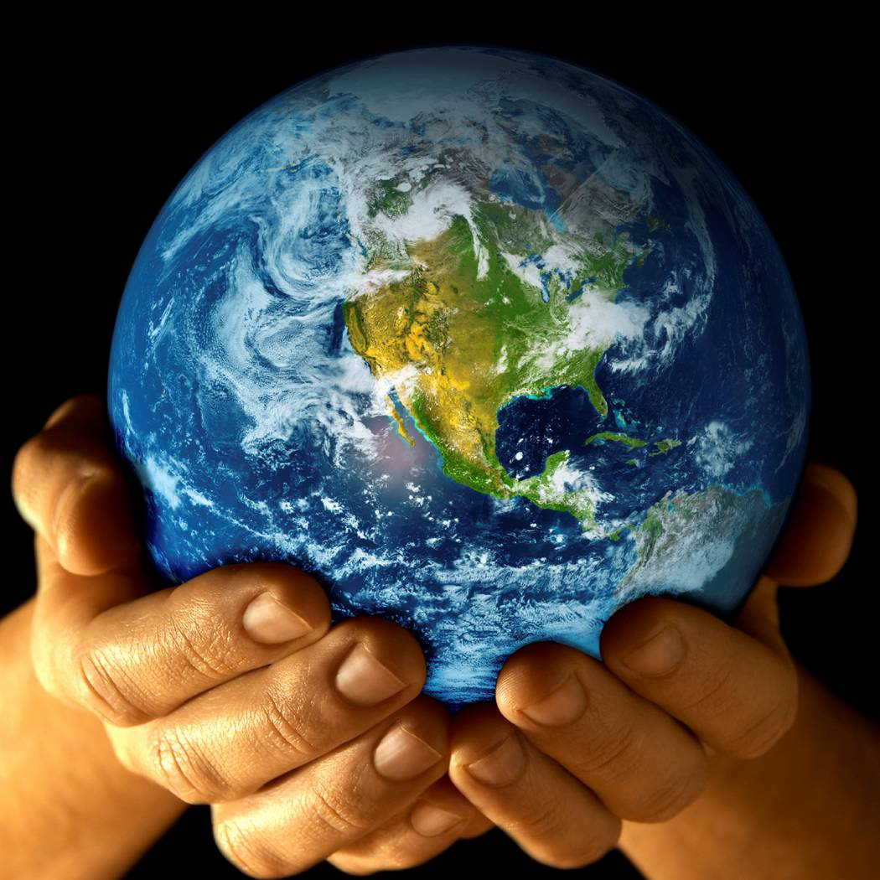
World Changers- Home learning
Thank you so much for all the wonderful home learning from our last topic. The children love sharing learning with their peers and it helps them grow in confidence to speak at the front of the class and answer question about their creations.
Please feel free to let the topic take your home learning in whatever direction you choose but if you are looking for some inspiration, please see the points below.

- Research a famous inventor and find out what they invented

- Create an invention for the future

- Write about ways we can help protect and look after the planet e.g. reducing waste and recycling more.

- Create a picture, powerpoint or model of Florence Nightingale or Mary Seacole.

- Research the Crimean war and which countries were involved.

- Write a story about life in the Crimean war imagining you were one of the nurses or soldiers.

- Create your own artwork using the image of the world.

- Make your own song about changing the world.

