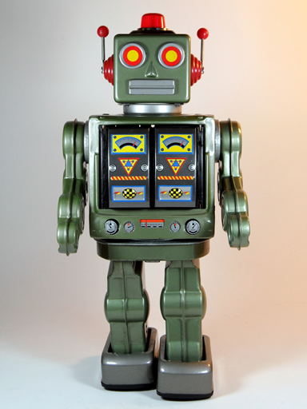
Home Learning Ideas
Rise of the Robots (Spring 1)

We really enjoy sharing home learning as it is great way for the children to explore the topic further, share their learning with you at home and demonstrate their independent skills.
Here are a few ideas of how you can bring this topic to life at home with your child but I’m sure they will also have some fantastic ideas:
- Create a job description for a robot – skills needed, the job role etc
- Find images of robots and put them into chronological order
- Research a specific robot and discover how it works
- Create a story about a robot
- Create a poem about robots
- Design and make your own robot (we will be doing this in school too)
- Write a set of instructions for a Year 1 or Year 2 child to tell them how to make a robot
- Research a range of artwork where robots are the focus. Can you create your own in a similar style?

