INTENT  We will explore and find out about people that have made inspired, achieved and made significant contributions both nationally and internationally. In DT, we will study historical inventors before designing and building their own inventions (Alexander Bell / The Wright Brothers). We will go back in time and decipher clues about Florence Nightingale and her achievements in changing nursing for the better. They will be inspired by the range of achievements and investigate and plan projects to change the world for one or more person. They will be motivated to dream of what they might achieve. The children have already been exposed to materials / environment etc and may choose to make links and apply this to their project. | 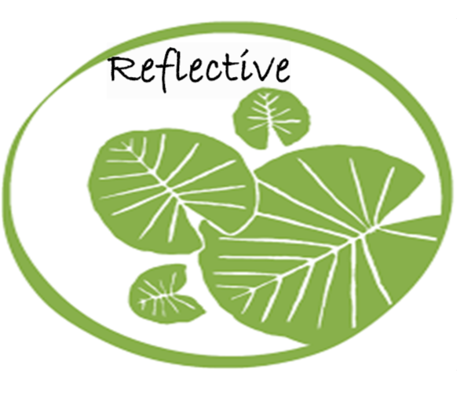  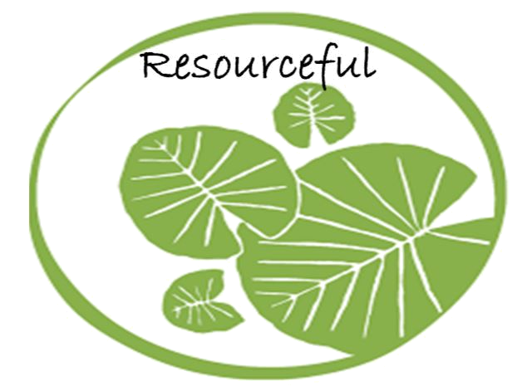  Independence | HISTORY
 |  | MUSIC
 |  | ENGLISH

HOOK

Inspiration quote and opportunity to create an abstract piece of art of the world.
ESSENTIAL QUESTION/CHALLENGE

“We do not need magic to change the world; we carry all the power we need inside ourselves already.” – J. K. Rowling
Do you agree? Argue your case.

OUTCOME

The children create their own invention for the future who could help one person or lots of people.

The children create a song in small groups/whole class about changing the world for the better.

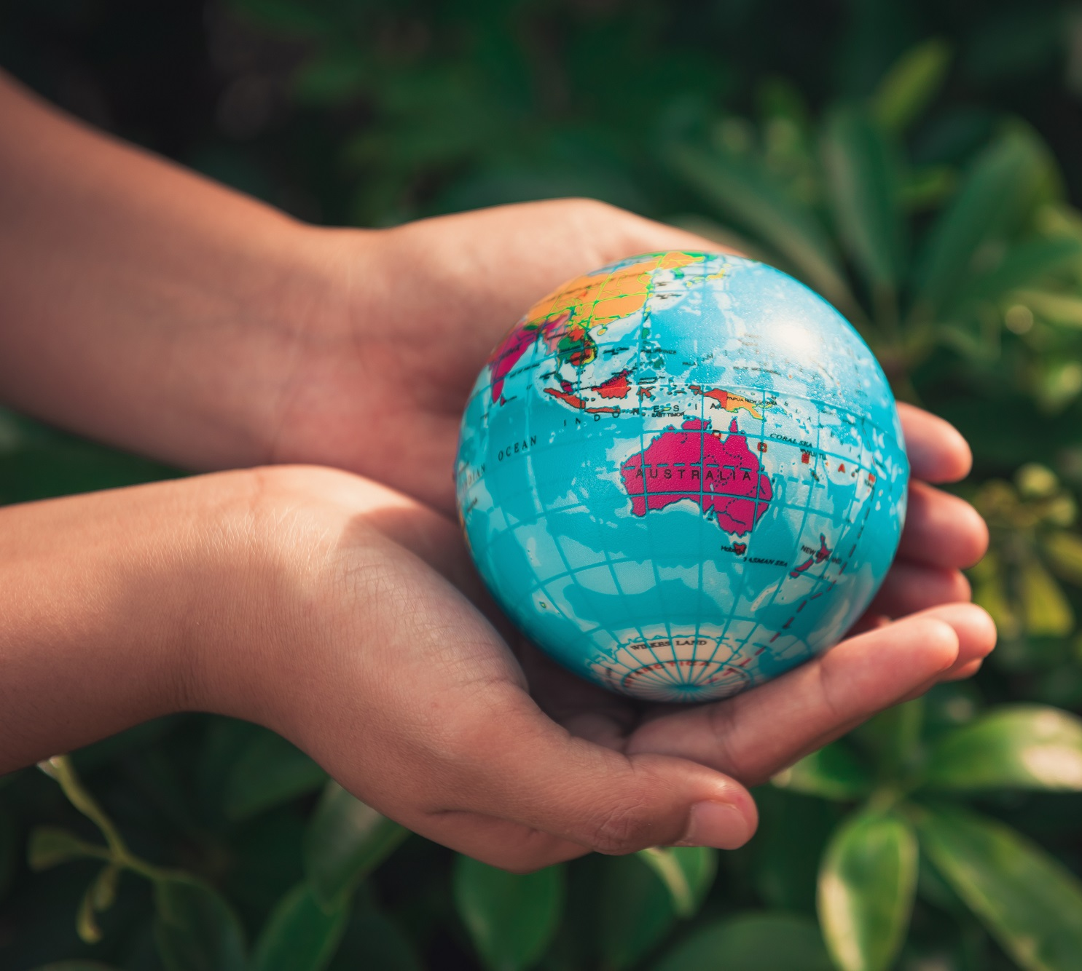
EXPERT INPUT

LEARNING THROUGH ROLE PLAY
Drama acting out Florence Nightingale looking after the soldiers.
Opportunities to create a scene in response to a piece of music.
Year 2
World changers
Spring 1

Learning in action. Developing an Inquiry Mind-set:  1. Knowledge (remember)  Match inventions to inventors.  Order transport through time.  Place inventions and inventors on a timeline.  Follow clues to understand why Wright brothers are famous.  Sort cards into before Florence Nightingale and changes that she made.  2. Comprehension (understand)  Summarise the work of a chosen inventor and how their designs impacted our lives.  Explain the work and inventions of Alexander Bell and The Wright Brothers.  Choose a source that proves that Wright brothers invented aeroplane.  Understand the importance of other significant inventors (Caroline Haslett).  Compare a modern day nurse/hospital to one before Florence Nightingale.  Can you convey the mood or meaning of a song by listening to it?  3. Application  Ask Florence Nightingale/Mary Seacole questions.  Write a diary entry as if you were Florence Nightingale or Mary Seacole.  Write a letter to Florence Nightingale’s parents persuading them to let you go to help in the Crimean War.  Create song words for our class change the world song  4. Analysis  Consider what life would be like without some inventions (e.g. wheels).  Discuss Florence’s and Mary’s life choices – opportunities for women in the past and whether it was fair.  Justify the impact that their new product will have on someone or a group of people.  5. Synthesize (create)  Design and present a new invention.  Test and make paper aeroplanes.  Predict what the outcome of your invention will be.  In small groups compose parts of the class song  6. Evaluation  Evaluate impact of past inventions.  Evaluate the changes that Florence Nightingale made to our hospitals. | As Historians we will:  - Understand the contributions that Florence Nightingale had on our lives.  - Sequence inventors and their inventions.  - Compare Florence Nightingale as a nurse and nurses now.  - Explain how nursing has changed over time.  - Consider how different inventions have changed our lives.  As Musicians we will:  - Listen to songs about changing the world/positive attitudes to encourage change (link with Jigsaw learning)  - Convey a mood or meaning of songs listened to and the song we create  - Work and perform in small groups to create our own song  - Sing words clearly and breathing at the end of phrases  As Designers we will:  - Evaluate the work of past inventors.  - Design, create and present a new invention.  - Compare our life with aeroplanes and what life was like before / without them. | Curriculum Objectives:  History  - The lives of significant individuals in the past who have contributed to national and international achievements. Some should be used to compare aspects of life in different periods. (For example Florence Nightingale)  - Changes within living memory  - Develop empathy and understanding of people in the past.  - Sequence artefacts, events and photos.  - Compare artefacts.  Music  - Pupils should be taught to: use their voices expressively and creatively by singing songs and speaking chants and rhymes  - play tuned and untuned instruments musically  - listen with concentration and understanding to a range of high-quality live and recorded music  - Experiment with, create, select and combine sounds using the inter-related dimensions of music.  DT  - critique, evaluate and test their ideas and products and the work of others  - explore and use mechanisms in their products.  - explore and evaluate a range of existing products  - design purposeful, functional, appealing products for themselves and other users based on design criteria  - generate, develop, model and communicate their ideas through talking, drawing, templates, mock-ups and, where appropriate, information and communication technology

How we evaluate?  *Thinking Hats will be used to reflect upon our overall outcomes at the end of the learning experience, ideas will be captured in their topic journals  *Peer and self-assessment will be used throughout the design process    *Concept mapping will provide formative assessment opportunities as the topic progresses and allow children to learn how to organise their gained knowledge and understanding |   What Stuck with you?  *Children can explain the changes that Florence Nightingale made to nursing and make comparisons between nursing then and now.  *Children can recognise the impact that some inventions have made on our lives, specifically Alexander Bell and the Wright Brothers.  *Children can evaluate the functionality, design and purpose of products.  Deeper Thinking  Children can create a valuable product, design or idea for someone or group of people to impact their lives for the better and justify their reasons for their design.
Wider and Discrete Learning Opportunities:
Science - Find out about and describe the basic needs of animals, including humans, for survival (Water, food and air) / Describe the importance for humans of exercise, eating the right amounts of different types of food, and hygiene. – Links to FN, clean water/hospitals etc.

Art – to develop a wide range of art and design techniques in using colour, pattern, texture, line, shape, form and space – Pop art self portraits / portraits of chosen role model.

Geography - Geographical skills and fieldwork: Use world maps, atlases and globes. - Use world maps, atlases and globes to identify the United Kingdom and its countries, continents and oceans studied at this key stage. – Use atlas’ to find Turkey and map the journey that FN took.
PSHE – Jigsaw- Dreams and Goals

Computing – Use technology safely and respectfully, keeping personal information private; identify where to go for help and support when they have concerns about content or contact on the internet or other online technologies

https://learnenglishkids.britishcouncil.org/short-stories/florence-nightingale
https://www.bbc.co.uk/teach/famous-people/zdqdscw

