 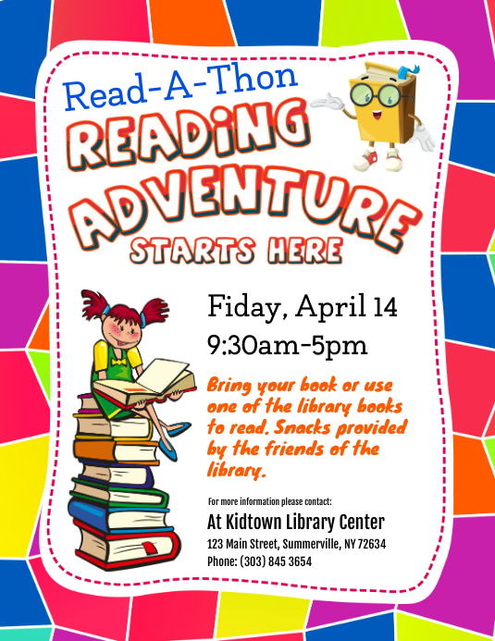



**Monday 21st February – Friday 4th March 2022!**

**We need your help!**

**We are fundraising to buy beautiful new books for our library and classrooms.**

All the details you need to take part are fully explained on the sponsor forms that will be sent home soon.

**The more you read, the more you’ll fundraise!**

**Fundraiser**

**Henbury’s**



